**11-3 What are habitats and niches?**

**Habitat** The place where an organism is its **habitat.** The habitat of an organism has the food and water the organism needs to live. An organism’s habitat also provides shelter and a place to reproduce.

There are many different kinds of habitats. Habitats can be very large or very small. There are land habitats and water habitats. An ocean is the habitat of a whale. The habitat of a woodpecker can be a forest. An anthill is a habitat.

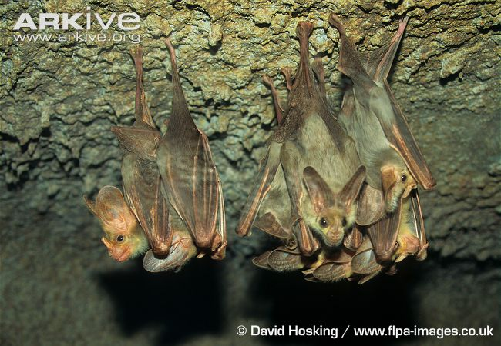 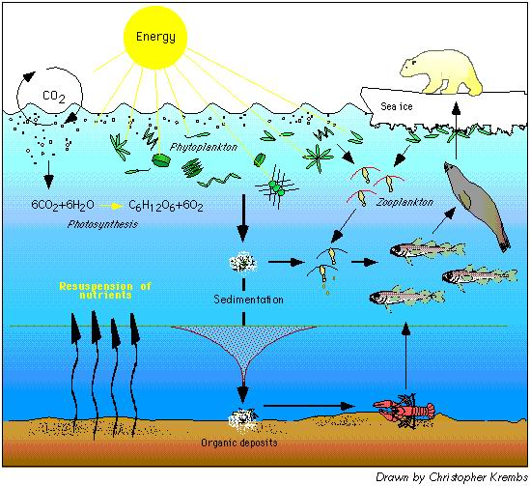

This cave is a habitat for many ghost bats. Polar bears, fish, and seals live in the same habitat but

have different niches.

**Niche** What is your role, or job, in life? Did you answer that you are a student? Being a student is the role that you carry out where you live. Organisms also have roles in their communities. The role of each organism is its **niche**. It includes everything an organism does and everything it needs.

**Different Niches**  Many kinds of organisms share the same habitat. Polar bears and seals both swim in the icy waters of the Arctic Ocean. They have different needs and roles in the habitat. Polar bears hunt seals and other animals. Seals feed on fish. Polar bears have one kind of shelter. Seals have another. They live in the same habitat, but they do not have the same niche.

Two populations cannot have the same niche for very long. For example, one animal may be able to hunt better and also find shelter better than another animal. The animals that hunt better or are better able to find shelter are more likely to survive and reproduce. Eventually, members of other populations may be crowded out. The niches of both population may also change so that both populations can adapt to one another.

11-3 What are habitats and niches?

Lesson Review

Answer the following questions.

**1.** What is a habitat?

**2.** Name four things that a habitat provides for an organism.

**3.** What is a niche?

**4.** What can happen if two populations share the same niche?

**5.** Name three organisms that share the same habitat.

Skill Challenge

**Skills:** classifying, researching

Identify the habitat in which each organism listed in the table below is most likely to live. Place a check mark in the correct column. Some organisms may have more than one habitat. Use reference materials if necessary.

|  |  |  |  |  |
| --- | --- | --- | --- | --- |
| Habitats | | | | |
| Organism | Desert | Forest | Salt Water | Fresh Water |
| **1.** Woodpecker |  |  |  |  |
| **2.** Cactus |  |  |  |  |
| **3.** Shark |  |  |  |  |
| **4.** Scorpion |  |  |  |  |
| **5.** Brook Trout |  |  |  |  |
| **6.** Rabbit |  |  |  |  |
| **7.** Seaweed |  |  |  |  |
| **8.** Tarantula |  |  |  |  |
| **9.** Fern |  |  |  |  |
| **10.** Oyster |  |  |  |  |
| **11.** Crayfish |  |  |  |  |
| **12.** Rattlesnake |  |  |  |  |

**CHECKING CONCEPTS**

1. A forest can be the of woodpeckers.

2. An organism’s habitat has the food and the organism needs to live.

3. The role of an organism in its habitat is its .

4. An anthill is an example of a .

5. If two populations have the same niche, the population best-suited to the niche will .